**TECHNOLOGIES: Year 7 Materials Design & Technology**

Design Portfolio

Project: CO2 Dragsters

**ASSESSMENT GRADES**

**Research and Planning A - B - C - D - E**

**Production A - B - C - D - E**

**Testing and Evaluation A - B - C - D - E**

Name: ………………………………….

Class: ……………………………………

**Learning Intentions:**

* To accurately measure and mark out metal pieces according to project plans
* To safely and efficiently use tools and machinery
* Identify design criteria for a successful product
* Develop product designs with reference to research and testing
* Communicate clearly through written work and production drawings
* Critically analyse own work to make informed decisions on areas for improvement

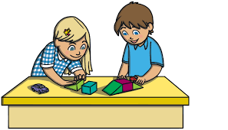

**7**

* Product constructed according to the project plans
* Work completed in a responsible and safe manner
* Relevant design criteria established.
* Final design shows reference to design concept sketches and research of existing ideas
* Final product is evaluated and areas for improvement are identified

**Success Criteria:**

Vocabulary List **Design and Technology terminology.**

|  |  |
| --- | --- |
| Word  Function | Definition:  ………………………………………………………………………………………………………………………………  ………………………………………………………………………………………………………………………………  How do you use this in Design and Technology?  ………………………………………………………………………………………………………………………………  ……………………………………………………………………………………………………………………………… |
| Word  Aesthetics | Definition:  ………………………………………………………………………………………………………………………………  ………………………………………………………………………………………………………………………………  How do you use this in Design and Technology?  ………………………………………………………………………………………………………………………………  ……………………………………………………………………………………………………………………………… |
| Word  Safety | Definition:  ………………………………………………………………………………………………………………………………  ………………………………………………………………………………………………………………………………  How do you use this in Design and Technology?  ………………………………………………………………………………………………………………………………  ……………………………………………………………………………………………………………………………… |
| Word  …………………………….. | Definition:  ………………………………………………………………………………………………………………………………  ………………………………………………………………………………………………………………………………  How do you use this in Design and Technology?  ………………………………………………………………………………………………………………………………  ……………………………………………………………………………………………………………………………… |
| Word  ……………………………… | Definition:  ………………………………………………………………………………………………………………………………  ………………………………………………………………………………………………………………………………  How do you use this in Design and Technology?  ………………………………………………………………………………………………………………………………  ……………………………………………………………………………………………………………………………… |
| Word  ……………………………… | Definition:  ………………………………………………………………………………………………………………………………  ………………………………………………………………………………………………………………………………  How do you use this in Design and Technology?  ………………………………………………………………………………………………………………………………  ……………………………………………………………………………………………………………………………… |

Vocabulary List **Tools used in Design and Technology**

|  |  |  |
| --- | --- | --- |
| **Name of Tool**  …………………………………… | What is the tool used for?  ……………………………………………………………………………….  ……………………………………………………………………………….  ……………………………………………………………………………….  ………………………………………………………………………………. | *Sketch or paste an image of the tool* |
| **Name of Tool**  …………………………………… | What is the tool used for?  ……………………………………………………………………………….  ……………………………………………………………………………….  ……………………………………………………………………………….  ………………………………………………………………………………. | *Sketch or paste an image of the tool* |
| **Name of Tool**  …………………………………… | What is the tool used for?  ……………………………………………………………………………….  ……………………………………………………………………………….  ……………………………………………………………………………….  ………………………………………………………………………………. | *Sketch or paste an image of the tool* |
| **Name of Tool**  …………………………………… | What is the tool used for?  ……………………………………………………………………………….  ……………………………………………………………………………….  ……………………………………………………………………………….  ………………………………………………………………………………. | *Sketch or paste an image of the tool* |
| **Name of Tool**  …………………………………… | What is the tool used for?  ……………………………………………………………………………….  ……………………………………………………………………………….  ……………………………………………………………………………….  ………………………………………………………………………………. | *Sketch or paste an image of the tool* |
| **Name of Tool**  …………………………………… | What is the tool used for?  ……………………………………………………………………………….  ……………………………………………………………………………….  ……………………………………………………………………………….  ………………………………………………………………………………. | *Sketch or paste an image of the tool* |

The Design Process

*There are four stages to the design process. Each step is vital in developing a successful product.*

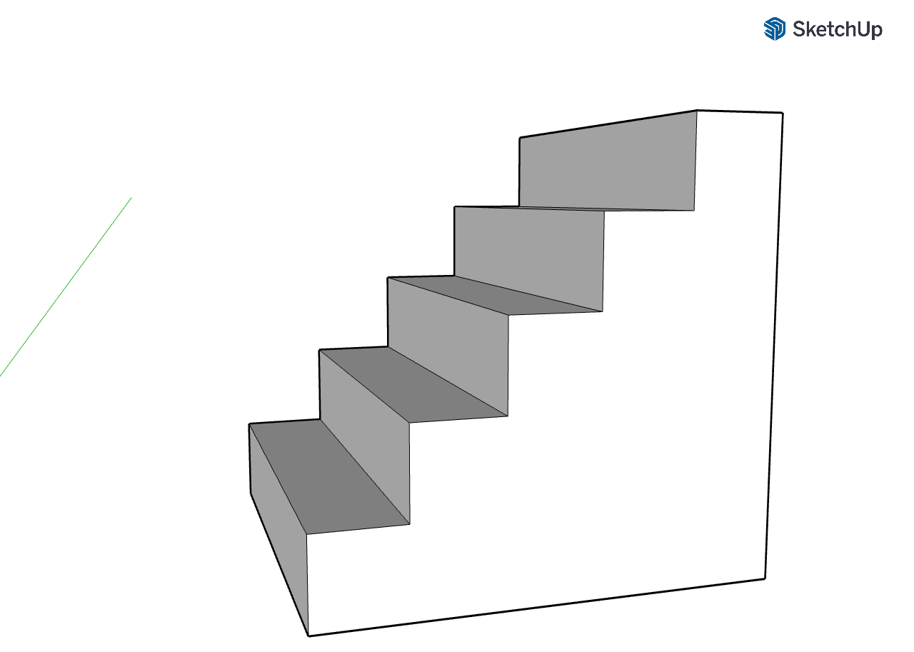

In the spaces on each step, list the tasks involved in each step of the Design Process.



TAKE

HOME!!



Testing

and Evaluation



Producing

and

Implementing



Research and

Planning

Identify and Defining



Identify and Defining

Identify and Defining

To **Identify and define** is the first step of the **design process**. In this step we are **identifying** the issue and **defining** specifically what challenges your design is to overcome, this is called a **criteria**.

**IDENDIFY THE NEED OR DESIGN OPPORTUNITY**.

……………………………………………………………………………………………………………………………………………………………………………………..

……………………………………………………………………………………………………………………………………………………………………………………..

**WHAT ARE THE DESIGN CRITERIA FOR A SUCCESSFUL DESIGN FOR YOUR PROJECT?**

…………………………………………………………………………………………………………………………………….

……………………………………………………………………………………………………………………………………

……………………………………………………………………………………………………………………………………

…………………………………………………………………………………………………………………………………..

…………………………………………………………………………………………………………………………………..

…………………………………………………………………………………………………………………………………..



Principle Forces Affecting CO2 Dragsters

Use the link provided to you below to write down what the following terms are, and how they affect CO2 Dragsters:

<https://auto.howstuffworks.com/auto-racing/motorsports/co2-powered-dragster2.htm>

Thrust:

……………………………………………………………………………………………………………………………………………………………………………………..

……………………………………………………………………………………………………………………………………………………………………………………..

……………………………………………………………………………………………………………………………………………………………………………………..

……………………………………………………………………………………………………………………………………………………………………………………..

Mass:

……………………………………………………………………………………………………………………………………………………………………………………..

……………………………………………………………………………………………………………………………………………………………………………………..

……………………………………………………………………………………………………………………………………………………………………………………..

……………………………………………………………………………………………………………………………………………………………………………………..

Friction:

……………………………………………………………………………………………………………………………………………………………………………………..

……………………………………………………………………………………………………………………………………………………………………………………..

……………………………………………………………………………………………………………………………………………………………………………………..

……………………………………………………………………………………………………………………………………………………………………………………..

Drag:

……………………………………………………………………………………………………………………………………………………………………………………..

……………………………………………………………………………………………………………………………………………………………………………………..

……………………………………………………………………………………………………………………………………………………………………………………..

……………………………………………………………………………………………………………………………………………………………………………………..

Materials Research

Use the links provided to you below to research information of the following types of wood:

**Balsa Wood:**

<https://www.wood-database.com/balsa/>

Scientific Name:

……………………………………………………………………………………………………………………………………………………………………………………..

Colour/Appearance:

……………………………………………………………………………………………………………………………………………………………………………………..

……………………………………………………………………………………………………………………………………………………………………………………..

Workability:

……………………………………………………………………………………………………………………………………………………………………………………..

……………………………………………………………………………………………………………………………………………………………………………………..

Pricing/Availability:

……………………………………………………………………………………………………………………………………………………………………………………..

……………………………………………………………………………………………………………………………………………………………………………………..

Sustainability:

……………………………………………………………………………………………………………………………………………………………………………………..

……………………………………………………………………………………………………………………………………………………………………………………..

Common Uses:

……………………………………………………………………………………………………………………………………………………………………………………..

……………………………………………………………………………………………………………………………………………………………………………………..

Review of Existing ideas

Research and Planning

**ASSESSMENT TASK**

Using the internet collect a minimum of 10 images that are inspiration for your potential design on your project. The images may be of existing products or any source of inspiration. Paste these images into a MS Word document (no larger than 1 page) with your name on the page and submit it on Compass for your teacher to print for you.

**Look at the images you have collected. Identify:**

- 3 design features in the images that you **LIKE** and why you would potentially like to incorporate these into your design.

- 3 design features you **DON’T LIKE** in the images and why you would not like to incorporate them into your design.

- 3 design features you find **INTERESTING** and state why you find them interesting.

**Write your answers next to the images.**

Design Concept Sketches **ASSESSMENT TASK**

In the space below, based on the designs on the previous page and any ideas you have developed on your own, sketch two potential block buddy designs you could produce on your project. These two designs can be variations of the same character or can be completely different if you want.

Design 1

Sketch you design in the space below

Design 1 Analysis

Describe your design?

…………………………………………………………………………………

…………………………………………………………………………………

…………………………………………………………………………………

…………………………………………………………………………………

Why do you like this design?

…………………………………………………………………………………

…………………………………………………………………………………

…………………………………………………………………………………

…………………………………………………………………………………

Design 2

Sketch you design in the space below

Design 2 Analysis

Describe your design?

…………………………………………………………………………………

…………………………………………………………………………………

…………………………………………………………………………………

…………………………………………………………………………………

Why do you like this design?

…………………………………………………………………………………

…………………………………………………………………………………

…………………………………………………………………………………

…………………………………………………………………………………

Final Design **ASSESSMENT TASK**

**ASSESSMENT MARK**

**A - B – C - D - E**

After consideration of BOTH of your designs and discussion with your teacher sketch below the final design you will produce for your project.

Why did you choose this design?

……………………………………………………………………………………………………………………………………………………………………………………

……………………………………………………………………………………………………………………………………………………………………………………

……………………………………………………………………………………………………………………………………………………………………………………

……………………………………………………………………………………………………………………………………………………………………………………

……………………………………………………………………………………………………………………………………………………………………………………

Project Production

Producing and Implementing

Producing and Implementing

On the drawing below, insert the required dimensions of your project

Materials List

|  |  |  |  |  |
| --- | --- | --- | --- | --- |
| **Component** | **Material** | **Width** | **Length** | **Quantity** |
|  |  |  |  |  |
|  |  |  |  |  |
|  |  |  |  |  |
|  |  |  |  |  |
|  |  |  |  |  |

Project Costings

In the space below, calculate the cost of the materials to produce your project

|  |  |  |  |  |  |
| --- | --- | --- | --- | --- | --- |
| **Component** | **Material** | **Cost of material** | **Size of material** | **Quantity needed** | **Working out** |
|  |  |  |  |  |  |
|  |  |  |  |  |  |
|  |  |  |  |  |  |
|  |  |  |  |  |  |
|  |  |  |  |  |  |
|  |  |  | Birmingham unveils Coalition’s policy costings |  | **Total Cost** |

Producing and Implementing

Production Journal

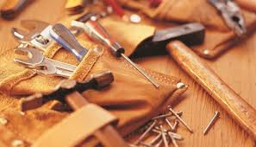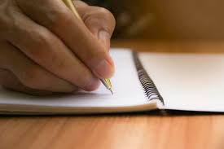

**STEP: 1**

**Description of step:** ...……………………………………………………………… …………………………………………………………………………………………………

…………………………………………………………………………………………………

…………………………………………………………………………………………………

**Tools required:** ………………………………………………………………………..

Sketch or photo of step

…………………………………………………………………………………………………

**Safety considerations:** …………………………………………………………………………………………………………………………………

………………………………………………………………………………………………………………………………………………………………………

**STEP: 2**

**Description of step:** ...……………………………………………………………… …………………………………………………………………………………………………

…………………………………………………………………………………………………

…………………………………………………………………………………………………

**Tools required:** ………………………………………………………………………..

Sketch or photo of step

…………………………………………………………………………………………………

**Safety considerations:** …………………………………………………………………………………………………………………………………

………………………………………………………………………………………………………………………………………………………………………

**STEP: 3**

**Description of step:** ...……………………………………………………………… …………………………………………………………………………………………………

…………………………………………………………………………………………………

…………………………………………………………………………………………………

**Tools required:** ………………………………………………………………………..

Sketch or photo of step

…………………………………………………………………………………………………

**Safety considerations:** …………………………………………………………………………………………………………………………………

………………………………………………………………………………………………………………………………………………………………………

**STEP: 4**

**Description of step:** ...……………………………………………………………… …………………………………………………………………………………………………

…………………………………………………………………………………………………

…………………………………………………………………………………………………

**Tools required:** ………………………………………………………………………..

Sketch or photo of step

…………………………………………………………………………………………………

**Safety considerations:** …………………………………………………………………………………………………………………………………

………………………………………………………………………………………………………………………………………………………………………

**STEP: 5**

**Description of step:** ...……………………………………………………………… …………………………………………………………………………………………………

…………………………………………………………………………………………………

…………………………………………………………………………………………………

**Tools required:** ………………………………………………………………………..

Sketch or photo of step

…………………………………………………………………………………………………

**Safety considerations:** …………………………………………………………………………………………………………………………………

………………………………………………………………………………………………………………………………………………………………………

**STEP: 6**

**Description of step:** ...……………………………………………………………… …………………………………………………………………………………………………

…………………………………………………………………………………………………

…………………………………………………………………………………………………

**Tools required:** ………………………………………………………………………..

Sketch or photo of step

…………………………………………………………………………………………………

**Safety considerations:** …………………………………………………………………………………………………………………………………

………………………………………………………………………………………………………………………………………………………………………

**STEP: 7**

**Description of step:** ...……………………………………………………………… …………………………………………………………………………………………………

…………………………………………………………………………………………………

…………………………………………………………………………………………………

**Tools required:** ………………………………………………………………………..

Sketch or photo of step

…………………………………………………………………………………………………

**Safety considerations:** …………………………………………………………………………………………………………………………………

………………………………………………………………………………………………………………………………………………………………………

**STEP: 8**

**Description of step:** ...……………………………………………………………… …………………………………………………………………………………………………

…………………………………………………………………………………………………

…………………………………………………………………………………………………

**Tools required:** ………………………………………………………………………..

Sketch or photo of step

…………………………………………………………………………………………………

**Safety considerations:** …………………………………………………………………………………………………………………………………

………………………………………………………………………………………………………………………………………………………………………

**STEP: 9**

**Description of step:** ...……………………………………………………………… …………………………………………………………………………………………………

…………………………………………………………………………………………………

…………………………………………………………………………………………………

**Tools required:** ………………………………………………………………………..

Sketch or photo of step

…………………………………………………………………………………………………

**Safety considerations:** …………………………………………………………………………………………………………………………………

………………………………………………………………………………………………………………………………………………………………………

**STEP: 10**

**Description of step:** ...……………………………………………………………… …………………………………………………………………………………………………

…………………………………………………………………………………………………

…………………………………………………………………………………………………

**Tools required:** ………………………………………………………………………..

Sketch or photo of step

…………………………………………………………………………………………………

**Safety considerations:** …………………………………………………………………………………………………………………………………

………………………………………………………………………………………………………………………………………………………………………

**STEP: 11**

**Description of step:** ...……………………………………………………………… …………………………………………………………………………………………………

…………………………………………………………………………………………………

…………………………………………………………………………………………………

**Tools required:** ………………………………………………………………………..

Sketch or photo of step

…………………………………………………………………………………………………

**Safety considerations:** …………………………………………………………………………………………………………………………………

………………………………………………………………………………………………………………………………………………………………………

**STEP: 12**

**Description of step:** ...……………………………………………………………… …………………………………………………………………………………………………

…………………………………………………………………………………………………

…………………………………………………………………………………………………

**Tools required:** ………………………………………………………………………..

Sketch or photo of step

…………………………………………………………………………………………………

**Safety considerations:** …………………………………………………………………………………………………………………………………

………………………………………………………………………………………………………………………………………………………………………

**STEP: 13**

**Description of step:** ...……………………………………………………………… …………………………………………………………………………………………………

…………………………………………………………………………………………………

…………………………………………………………………………………………………

**Tools required:** ………………………………………………………………………..

Sketch or photo of step

…………………………………………………………………………………………………

**Safety considerations:** …………………………………………………………………………………………………………………………………

………………………………………………………………………………………………………………………………………………………………………

**STEP: 14**

**Description of step:** ...……………………………………………………………… …………………………………………………………………………………………………

…………………………………………………………………………………………………

…………………………………………………………………………………………………

**Tools required:** ………………………………………………………………………..

Sketch or photo of step

…………………………………………………………………………………………………

**Safety considerations:** …………………………………………………………………………………………………………………………………

………………………………………………………………………………………………………………………………………………………………………

**STEP: 15**

**Description of step:** ...……………………………………………………………… …………………………………………………………………………………………………

…………………………………………………………………………………………………

…………………………………………………………………………………………………

**Tools required:** ………………………………………………………………………..

Sketch or photo of step

…………………………………………………………………………………………………

**Safety considerations:** …………………………………………………………………………………………………………………………………

………………………………………………………………………………………………………………………………………………………………………

Design Review **ASSESSMENT TASK**

Testing and Evaluation

The first task you completed before designing your product was to determine the **design criteria for a successful design.**

List the design criteria in the spaces below and determine whether you were successful in achieving this goal? **Justify** why you think you were successful or explain what went wrong if you think you were unsuccessful.



**Design Criteria**

**……………………………………………………………………………………………………………………………………………………**

How did you achieve this goal?

………………………………………………………………………………………………………………………………………………………..

………………………………………………………………………………………………………………………………………………………..

**Design Criteria**

**……………………………………………………………………………………………………………………………………………………**

How did you achieve this goal?

………………………………………………………………………………………………………………………………………………………..

………………………………………………………………………………………………………………………………………………………..

**Design Criteria**

**……………………………………………………………………………………………………………………………………………………**

How did you achieve this goal?

………………………………………………………………………………………………………………………………………………………..

………………………………………………………………………………………………………………………………………………………..

**Design Criteria**

**……………………………………………………………………………………………………………………………………………………**

How did you achieve this goal?

………………………………………………………………………………………………………………………………………………………..

………………………………………………………………………………………………………………………………………………………..

**Design Criteria**

**……………………………………………………………………………………………………………………………………………………**

How did you achieve this goal?

………………………………………………………………………………………………………………………………………………………..

………………………………………………………………………………………………………………………………………………………..

Design Criteria

Design Reflection **ASSESSMENT TASK**

1. Was your product attractive to look at? Why was it’s appearance (aesthetics) good or bad?

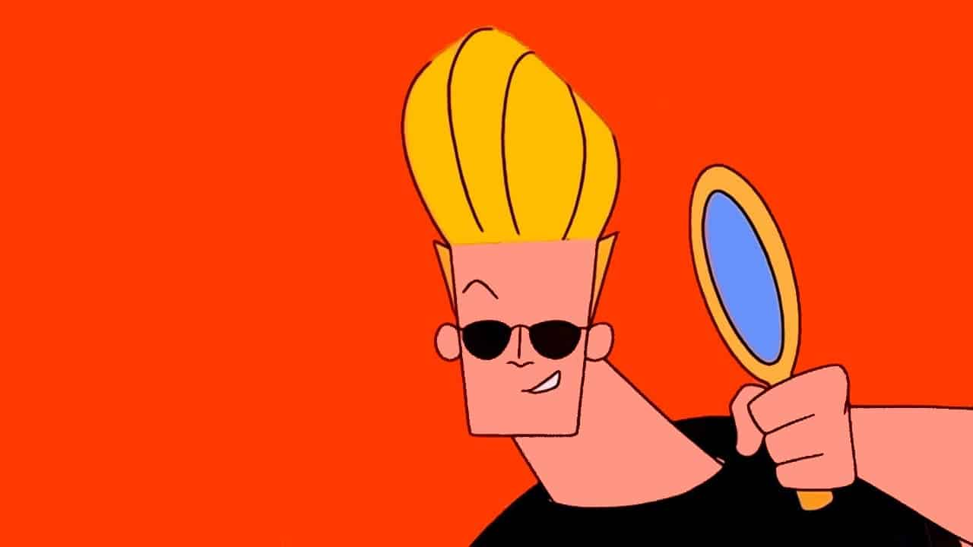……………………………………………………………………………………………………………………

……………………………………………………………………………………………………………………

……………………………………………………………………………………………………………………

……………………………………………………………………………………………………………………

……………………………………………………………………………………………………………………

1. How could you improve the aesthetics of your product?

…………………………………………………………………………………………………………………………………………………………………………………….

…………………………………………………………………………………………………………………………………………………………………………………….

…………………………………………………………………………………………………………………………………………………………………………………….

1. Did your product function well in it’s desired use? Explain why it did or did not function well.

……………………………………………………………………………………………………………………………

……………………………………………………………………………………………………………………………

……………………………………………………………………………………………………………………………

1. Was your product safe to use? Explain why your product was either safe or not safe to use.

…………………………………………………………………………………………………………………………………………………………………………………….

…………………………………………………………………………………………………………………………………………………………………………………….

…………………………………………………………………………………………………………………………………………………………………………………….

1. How could you improve the safe use of your product even more?

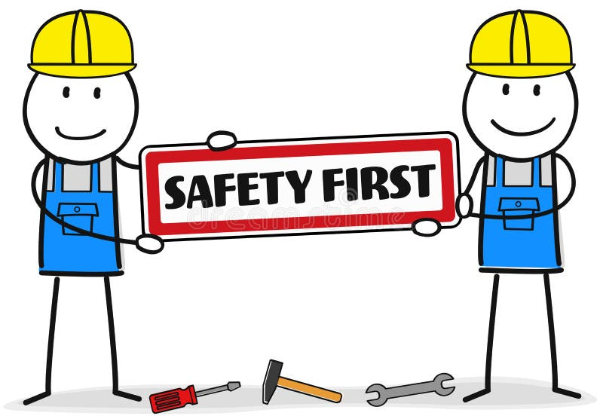……………………………………………………………………………………………………

……………………………………………………………………………………………………

……………………………………………………………………………………………………

…………………………………………………………………………………………………..

……………………………………………………………………………………………………

…………………………………………………………………………………………………..

Personal Growth

1. Name one aspect of the construction of you project that you found difficult. Why did you find that stage difficult?

**Something I found difficult:** **………………………………………………………**

…………………………………………………………………………………………………………

…………………………………………………………………………………………………………

…………………………………………………………………………………………………………

…………………………………………………………………………………………………………

…………………………………………………………………………………………………………

…………………………………………………………………………………………………………

*Sketch the stage you found most difficult*

…………………………………………………………………………………………………………

…………………………………………………………………………………………………………………………………………………………………………………….

……………………………………………………………………………………………………………………………………………………………………………………

1. Describe one new skill that you learnt during the production of your product

**A new skill I learnt: ………………………………………………………………**

…………………………………………………………………………………………………………

…………………………………………………………………………………………………………

…………………………………………………………………………………………………………

…………………………………………………………………………………………………………

…………………………………………………………………………………………………………

…………………………………………………………………………………………………………

*Sketch the new skill you learnt*

…………………………………………………………………………………………………………

……………………………………………………………………………………………………………………………………………………………………………………

……………………………………………………………………………………………………………………………………………………………………………………



Areas for improvement **ASSESSMENT TASK**

1. Describe one change that could be made to your design. The change can be to improve **appearance or functionality**.

……………………………………………………………………………………………………………………………………………………………………………………..

……………………………………………………………………………………………………………………………………………………………………………………..

……………………………………………………………………………………………………………………………………………………………………………………..

……………………………………………………………………………………………………………………………………………………………………………………..

……………………………………………………………………………………………………………………………………………………………………………………..

……………………………………………………………………………………………………………………………………………………………………………………..

*Sketch the change that you would make to the pencil slide box design*

1. Why do you think this change would improve the design?

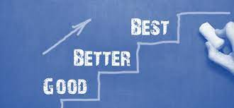……………………………………………………………………………………………

………………………………………………………………………………………..…

……………………………………………………………………………………………

……………………………………………………………………………………………

……………………………………………………………………………………………

**ASSESSMENT MARK**

**A - B - C - D - E**

STEAM Skills

Look at the list of STEAM Skills below. Identify three STEAM skills that you utilised in the completion of this project and describe how you used them.

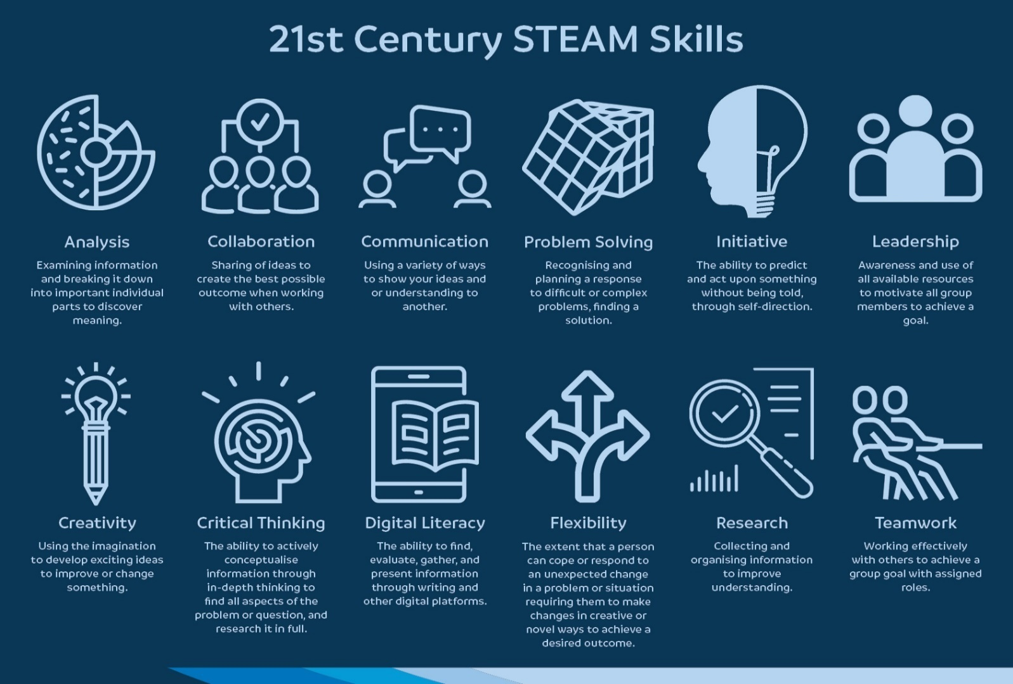

**STEAM Skill 1: …………………………………………………**

Describe how you used this skill: ………………………………………………………………………………………………………………………………….

……………………………………………………………………………………………………………………………………………………………………………………..

……………………………………………………………………………………………………………………………………………………………………………………..

**STEAM Skill 2: …………………………………………………**

Describe how you used this skill: ………………………………………………………………………………………………………………………………….

……………………………………………………………………………………………………………………………………………………………………………………..

……………………………………………………………………………………………………………………………………………………………………………………..

**STEAM Skill 3: …………………………………………………**

Describe how you used this skill: ………………………………………………………………………………………………………………………………….

……………………………………………………………………………………………………………………………………………………………………………………..

……………………………………………………………………………………………………………………………………………………………………………………..

**Additional Notes**

……………………………………………………………………………………………………………………………………………………………………………

……………………………………………………………………………………………………………………………………………………………………………

……………………………………………………………………………………………………………………………………………………………………………

……………………………………………………………………………………………………………………………………………………………………………

……………………………………………………………………………………………………………………………………………………………………………

……………………………………………………………………………………………………………………………………………………………………………

……………………………………………………………………………………………………………………………………………………………………………

……………………………………………………………………………………………………………………………………………………………………………

……………………………………………………………………………………………………………………………………………………………………………

……………………………………………………………………………………………………………………………………………………………………………

……………………………………………………………………………………………………………………………………………………………………………

……………………………………………………………………………………………………………………………………………………………………………

……………………………………………………………………………………………………………………………………………………………………………

……………………………………………………………………………………………………………………………………………………………………………

**Production Assessment and Feedback**

**Student Name:** ………………………………………….

**Project:** ……………………………………………………..

**Design Portfolio Marking Key**

|  |  |  |  |  |  |
| --- | --- | --- | --- | --- | --- |
|  | **A**  **Excellent Achievement** | **B**  **High Achievement** | **C**  **Satisfactory Achievement** | **D**  **Limited Achievement** | **E**  **Very Low Achievement** |
| **Technologies and Society** | Identifies competing factors, including social, ethical and sustainability in the development of technologies, with supporting examples. | Identifies competing factors, including social, ethical and sustainability in the development of technologies | Recognises competing factors, including social, ethical and sustainability in the development of technologies. | Lists some ways products, services and/or environments evolve, recalling few social and/or ethical and/or sustainability factors in the development of technologies. | Does not meet the requirements of a D grade. |
| **Materials and Technologies Specalisations** | Explains how the selection of material and technology processes are influenced by the combination of materials, systems, components, tools and equipment, considering efficiency. | Describes how the selection of material and technology processes are influenced by the combination of materials, systems, components, tools and equipment. | Identifies how the selection of material and technology processes are influenced by the combination of materials, systems, components, tools and equipment. | Selects materials, components, tools, equipment and/or systems, with minimal consideration of materials and technologies processes. | Does not meet the requirements of a D grade. |
| **Investigating and Defining** | Describes constraints and lists components/resources to consider when developing solutions. | Identifies constraints and lists components/resources to consider when developing solutions. | Identifies constraints and considers components/resources to develop solutions. | Lists some familiar components and/or resources to develop solutions. | Does not meet the requirements of a D grade. |
| **Designing** | Uses a wide range of techniques, appropriate technical terms and technologies to design, develop, review and clearly communicate comprehensive design ideas, detailed plans and processes. | Uses a range of techniques, appropriate technical terms and technologies to design, develop, review and clearly communicate design ideas, detailed plans and processes. | Uses a range of techniques, appropriate technical terms and technologies to design, develop, review and communicate design ideas, plans and processes. | Uses a few techniques, technical terms and technologies to design, communicate, develop and/or review brief design ideas, plans and/or processes. | Does not meet the requirements of a D grade. |
| **Collaborating and Managing** | Consistently works independently, and collaboratively, to plan, develop and effectively communicate detailed and logical ideas and information, using management processes. | Works independently, and collaboratively, to plan, develop and effectively communicate logical ideas and information, using management processes. | Works independently, and collaboratively, to plan, develop and communicate ideas and information, using management processes. | Sometimes works independently, and collaboratively, to plan simple ideas, using some management processes. | Does not meet the requirements of a D grade. |

**Evaluation Marking Key**

|  |  |  |  |  |  |
| --- | --- | --- | --- | --- | --- |
|  | **A**  **Excellent Achievement** | **B**  **High Achievement** | **C**  **Satisfactory Achievement** | **D**  **Limited Achievement** | **E**  **Very Low Achievement** |
| **Evaluating** | Applies given contextual criteria to independently and comprehensively evaluate design processes and solutions, and provides detailed reflections. | Applies given contextual criteria to independently evaluate design processes and solutions, and provides detailed reflections. | Applies given contextual criteria to independently evaluate design processes and solutions. | Applies given contextual criteria to briefly review design processes and/or solutions. | Does not meet the requirements of a D grade. |
| **Collaborating and Managing** | Consistently works independently, and collaboratively, to plan, develop and effectively communicate detailed and logical ideas and information, using management processes. | Works independently, and collaboratively, to plan, develop and effectively communicate logical ideas and information, using management processes. | Works independently, and collaboratively, to plan, develop and communicate ideas and information, using management processes. | Sometimes works independently, and collaboratively, to plan simple ideas, using some management processes. | Does not meet the requirements of a D grade. |

**Production Marking Key**

|  |  |  |  |  |  |
| --- | --- | --- | --- | --- | --- |
|  | **A**  **Excellent Achievement** | **B**  **High Achievement** | **C**  **Satisfactory Achievement** | **D**  **Limited Achievement** | **E**  **Very Low Achievement** |
| **Producing and Implementing** | Selects and consistently applies safe and appropriate procedures to make solutions, using a wide range of components, equipment and techniques. | Selects and applies safe and appropriate procedures to make solutions, using a range of components, equipment and techniques. | Applies safe procedures to make solutions, using a range of components, equipment and techniques. | Follows some safe procedures to make solutions, using familiar and/or given components, equipment and techniques. | Does not meet the requirements of a D grade. |
| **Collaborating and Managing** | Consistently works independently, and collaboratively, to plan, develop and effectively communicate detailed and logical ideas and information, using management processes. | Works independently, and collaboratively, to plan, develop and effectively communicate logical ideas and information, using management processes. | Works independently, and collaboratively, to plan, develop and communicate ideas and information, using management processes. | Sometimes works independently, and collaboratively, to plan simple ideas, using some management processes. | Does not meet the requirements of a D grade. |