Make A Statement Part 1 - Design

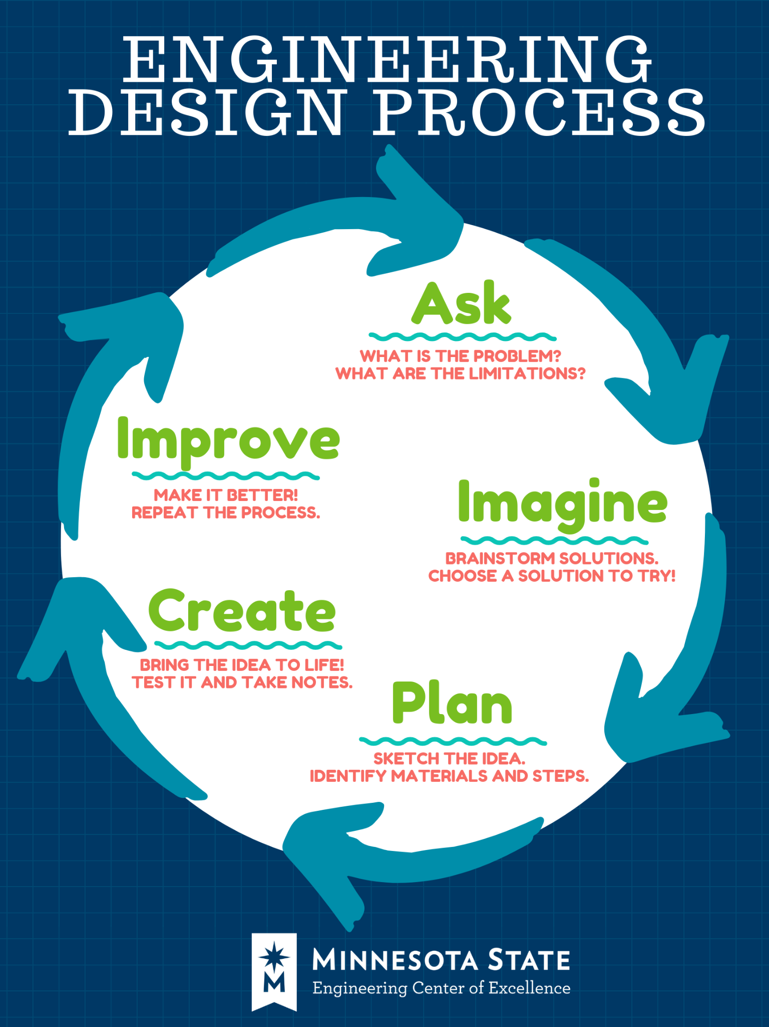
1) What is the goal of the project?
Write a brief statement of what you are going to do.

2) What messages have you been told or seen?
Fill in examples of messages - they can all be from the same category or different ones
Here are a few sample topics: Religion, Race, Gender, Food, Environment, Economics

These message may be true or false

You can also search for images that have the message - for example: google “protest sign”
Topic | Message |  | Positive, Negative, Neutral | True or False
Race | Black Lives Matter |  | Positive | True
Race | Black people in hoodies are dangerous |  | Negative | False
Justice | 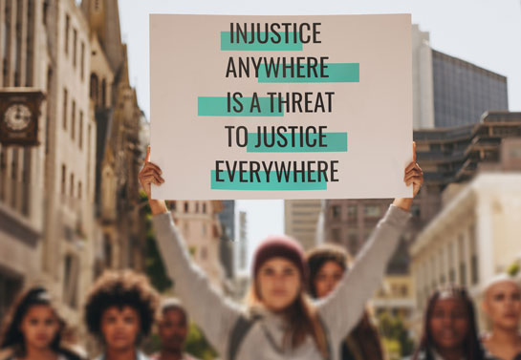 |  | Neutral | True

3) Find examples that already exist
Find (use Google) and post 5 pictures of items with a message that you like
Need help? Try using these keywords: ex. t-shirt with _____ message or ____ cause
- Social, political, environmental, racial, economic

4) Make a variety of designs
Use an online program to create 3 different designs

- https://www.adobe.com/express/create
- https://www.canva.com/
- https://www.photopea.com/
- Coreldraw (on computer)
- Inkscape (on computer)

Paste a picture of your designs here:

Design 1:

Design 2:

Design 3:

5) Choosing the best design

- Find a definition for the following terms: please cite where you go the definition from
- Evaluate
- Analyze
- Criteria

- Write a definition of each term in your own words

- Choose 3 criteria to analyze your design and make a table to evaluate the design

Criteria | Design 1 | Design 2 | Design 3
total

What is your ranking or rating scale? Pick one! Be consistent! Highlight 1 please

1-10 where 10 is the best, 1-10 where 1 is the best, 1-3 where 1 is the best, 1-3 where 3 is the best

Which design is the best and why - refer to your chart!!

Make A Statement Part 2 - Product

6) Create your item!
If you haven’t done so already, use a digital program or draw your design by hand to get the final design. Make your item using the necessary equipment!

Insert a .jpg file of the final product here!

7) Feedback / Improve
- How did it turn out?
- Would you do anything differently?
- What was the hardest part?
- What was the most interesting part?
- Would you want to make another design in the future?

