Instructions to add shapes to Bookmark Frame
1) Create a copy (TempFrame) of one of the project frames (MainFrame)
2) Add the shape behind the frame.

3) Select both and click ‘Path’ then ‘Difference’
4) The Shape will now have the frame cut into it and the TempFrame will be gone
5) Select the image, click ‘Path’ then ‘Fracture’
6) Select the unwanted piece and delete
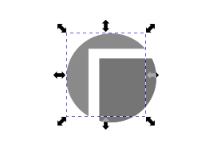

7) Move the remaining piece to your frame and position it correctly
8) Select both and click ‘Path’ then ‘Union’
9) The image is now part of your MainFrame

